

<!DOCTYPE html>

<html lang="en">

<head>

<title>Bootstrap Example</title>

<meta charset="utf-8">

<meta name="viewport" content="width=device-width, initial-scale=1">

**<link rel="stylesheet" href="https://maxcdn.bootstrapcdn.com/bootstrap/3.4.1/css/bootstrap.min.css">**

**<script src="https://ajax.googleapis.com/ajax/libs/jquery/3.5.1/jquery.min.js"></script>**

**<script src="https://maxcdn.bootstrapcdn.com/bootstrap/3.4.1/js/bootstrap.min.js"></script>**

</head>

<body>

<div class="container">

<div class="progress">

<div class="progress-bar" role="progressbar"

aria-valuenow="70"

aria-valuemin="0"

aria-valuemax="100"

style="width:70%">

70%

</div>

</div>

</div>

</body>

</html>

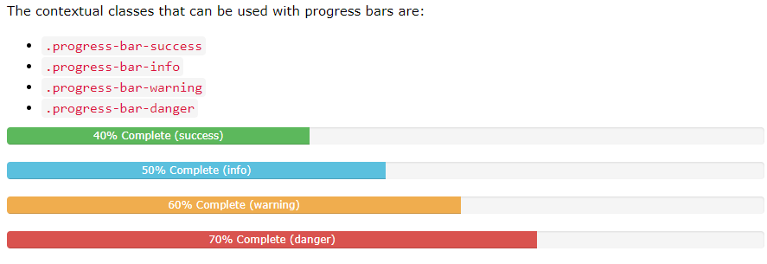

<div class="progress">  
  <div class="progress-bar progress-bar-success" role="progressbar" aria-valuenow="40"  
  aria-valuemin="0" aria-valuemax="100" style="width:40%">  
    40% Complete (success)  
  </div>  
</div>  
  
<div class="progress">  
  <div class="progress-bar progress-bar-info" role="progressbar" aria-valuenow="50"  
  aria-valuemin="0" aria-valuemax="100" style="width:50%">  
    50% Complete (info)  
  </div>  
</div>  
  
<div class="progress">  
  <div class="progress-bar progress-bar-warning" role="progressbar" aria-valuenow="60"  
  aria-valuemin="0" aria-valuemax="100" style="width:60%">  
    60% Complete (warning)  
  </div>  
</div>  
  
<div class="progress">  
  <div class="progress-bar progress-bar-danger" role="progressbar" aria-valuenow="70"  
  aria-valuemin="0" aria-valuemax="100" style="width:70%">  
    70% Complete (danger)  
  </div>  
</div>

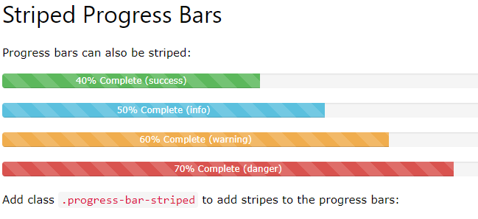

<div class="progress">  
  <div class="progress-bar

progress-bar-success

progress-bar-striped"

role="progressbar"  
  aria-valuenow="40" aria-valuemin="0" aria-valuemax="100" style="width:40%">  
    40% Complete (success)  
  </div>  
</div>

Animated Progress Bar !!!!

40%

Add class .active to animate the progress bar:

Example

<div class="progress">  
  <div class="progress-bar progress-bar-striped active"

role="progressbar"  
  aria-valuenow="40" aria-valuemin="0" aria-valuemax="100" style="width:40%">  
    40%  
  </div>  
</div>

Stacked Progress Bars

Progress bars can also be stacked:



Create a stacked progress bar by placing multiple bars into the same

<div class="progress">:

Example

<div class="progress">

  <div class="progress-bar progress-bar-success"

role="progressbar" style="width:40%">  
    Free Space  
  </div>

  <div class="progress-bar progress-bar-warning" role="progressbar" style="width:10%">  
    Warning  
  </div>

  <div class="progress-bar progress-bar-danger" role="progressbar" style="width:20%">  
    Danger  
  </div>

</div>